Part C

System & Design

System Architecture Overview:
Cyber guard system follows a centralized multi-agent architecture, the core of the system is the founder who acts as the primary decision maker. Our system Architecture is designed in specific way that makes the system interconnected and working in an organized manner not just random operations. So it consists of:

Management layer:
The primary entry point where tasks and operations are defined, and get final strategic decisions authorized.

Processing core:
A specialized layer consisting 5 autonomous agents, each agent is programed to preform functions as an object oriented entity capable of interpreting specific data sets related to its domain such as ( e.g., security risks , financial costs or client response).

Data persistence:

This layer ensures that the system is not "stateless" , by programming agents to interact with the memory component to checks of any historical interactions and industry-standard rules were made before, this can easily assist agents in generating high-quality recommendations.

Feedback loop:

A structured reporting mechanism that aggregates findings from all agents into a unified dashboard for the founder. The founder have the permission to accept or deny the recommendations that were made by the agents.

Multi-Agent Structure:

Agent 1: Security Vulnerability Agent
. Agent Name: Vulnerability Scanner
. Responsibilities: Identifying technical weaknesses in client systems and suggesting security patches to achieve CIA.
. Type of Tasks Handled: Technical security auditing and code review.
. Information Processed: System logs, source code, and network configurations.
Agent 2: Risk Assessment Agent
. Agent Name: Risk evaluator
. Responsibilities: calculating the impact of security threat and assigning a priority level (High/Low).
. Type of Tasks Handled: Strategy and prioritization.
. Information Processed: Threat intelligence data and business impact metrics.

Agent 3: Financial Management Agent
. Agent Name: Bob the finance
. Responsibilities: Managing service pricing, generating invoices, and tracking the company's profit.
. Type of Tasks Handled: Accounting and financial reporting.
. Information Processed: Service hours, fixed costs, and client payment history.

Agent 4: Client Communication Agent
Agent Name: Client service. .
. Responsibilities: Translating technical reports into easy-to-understand language for the client.
. Type of Tasks Handled: Customer service and simplified report.
. Information Processed: Technical agent reports and client contact details.

Agent 5: Market Trends Agent
. Agent Name: Threat Intelligence Scout.
. Responsibilities: Monitoring the latest global cyber-attacks to update the company’s services.
. Type of Tasks Handled: Market research and proactive updates.
. Information Processed: Global cybersecurity news and competitor pricing.

System Classes:

1.Class company
The main class that contain all elements. It contain the name of the company, agents list and the current budget.

2. Class Founder:

The decision maker.

3. Class agent:

The class that all agents inherits from.

4. Class Task

The task that the system is preforming on the time.

5. Class Memory

This class is responsible for saving the latest operations.

6. Class Knowledgebase

It contains the rules and data that agents rely on in their analysis.

7. Class Recommendation / Report

It represents the final output that each agent presents to the founder.

UML Class Diagram

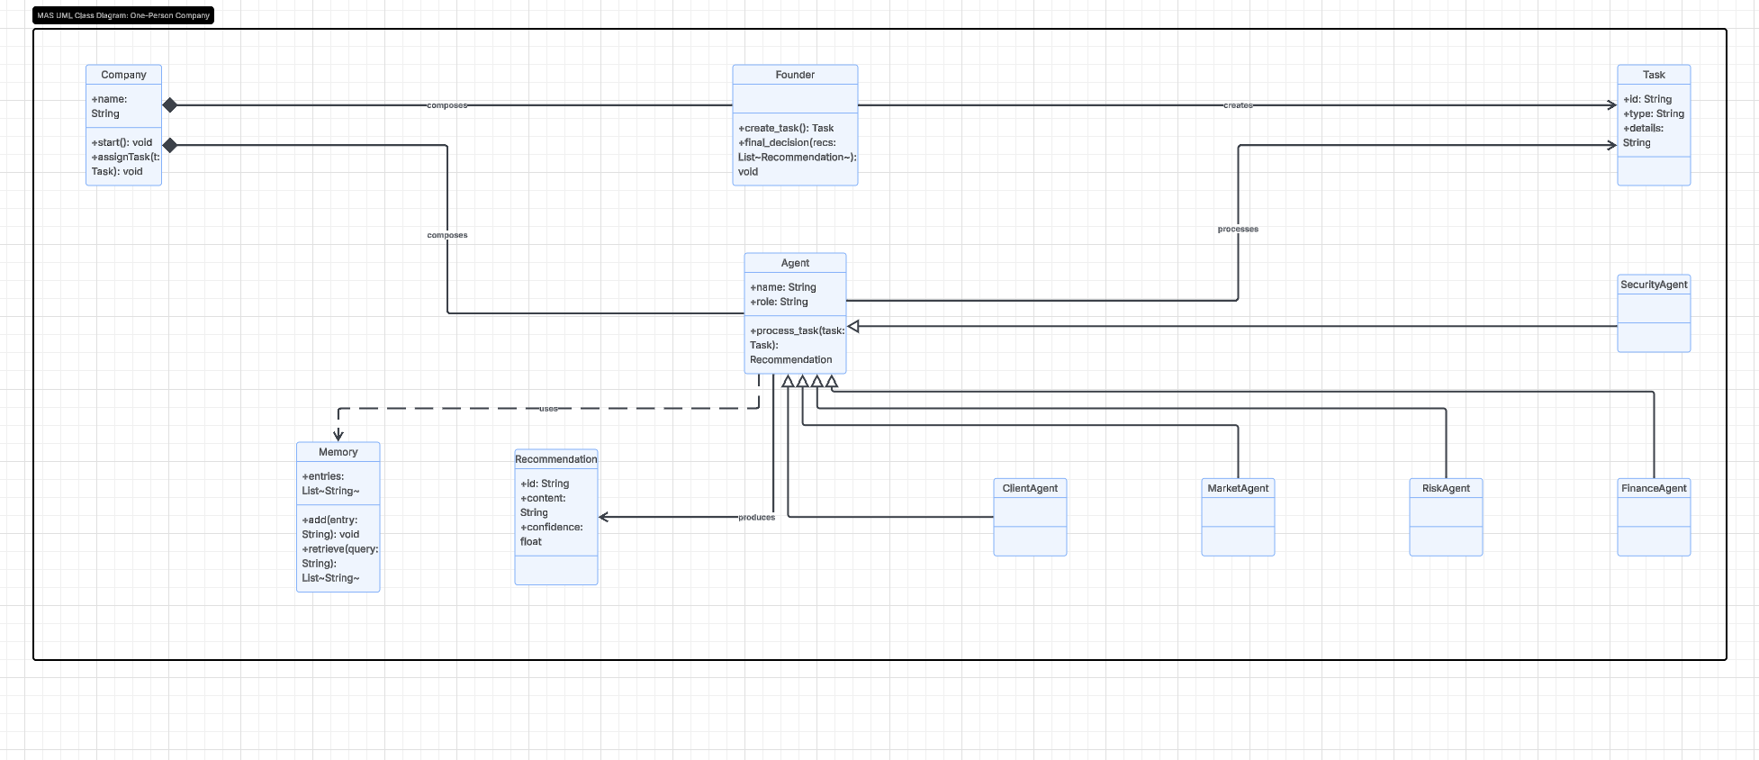

This diagram represents the structural blueprint of the CyberGuard Solo system. It illustrates how the different components interact using Object-Oriented Programming (OOP) principles
Inheritance the five specialized agents (Security, Finance, Risk, Client, and Market) all point to the Agent base class with a hollow arrow. This shows that they inherit the same foundation but perform different specialized tasks.
Composition the Company class is connected to the Founder and Agents using a solid diamond shape. This indicates that the company "owns" and is composed of these essential parts.

How system works :
The Founder initiates the process by creating a Task.
The Agents process this task and produce a Recommendation.
The Memory class stores all historical data to assist in future decision-making.
Final Output: The relationships show a clear flow from "Defining a Problem" (Task) to "Expert Analysis" (Agents) and finally "Strategic Decision" (Founder).

